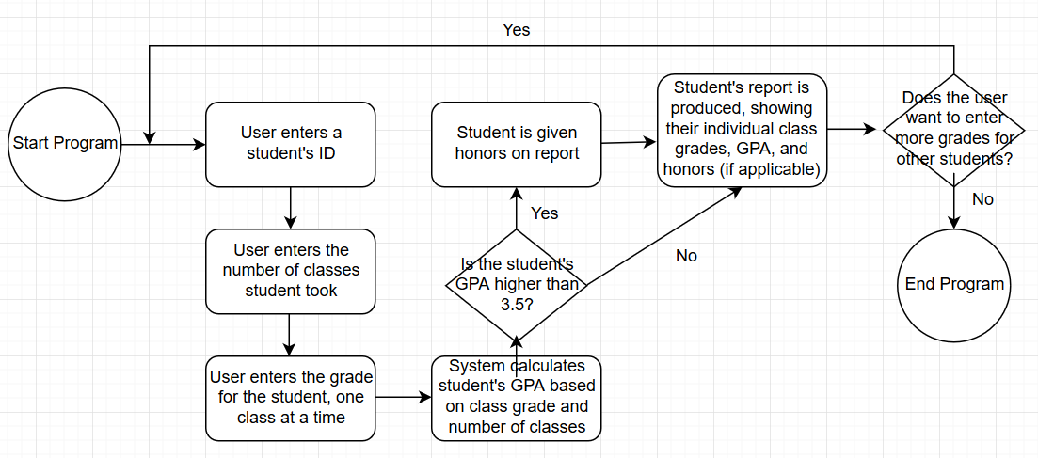

Possible classes to include:

* Student: contains information such as the student’s ID, courses student has taken and their GPA
* Class: contains information such as the class names and the number of credits given by each class and sends the values back to the Student class
* Grade Point Average (GPA): calculates GPA and sends the value back to the Student class

Possible files to include:

* GradeTrackingSystem.h: contains information for the headers for each of our non-Main classes
* GradeTrackingSystem.cpp: contains information for the bodies for each of our non-Main classes
* GTSMain.cpp: contains information on the Main class